ChE 433 – Process Simulation with ASPEN Plus –Fall 2019
Student Learning Outcome 2

Rubric for assessment problem on Homework Problems 4 and 5

4A .Summary of results for both problems (about one page)
4B. Flowsheets for both processes
4C. Heat and Weight Balance
4D. List of Equipment with the capital costs (see example below)
4E. List of Utilities/Raw Material/Product with operating costs

4A. Outline your steps you followed to reach your final column design
4B. Final process flowsheet printout
4C. ASPEN report for the distillation column
4D. Heat and Weight Balance for the entire unit
4E. List of all equipment for with the capital costs (see example below)
4F. List of utilities, raw materials and products with operating costs

SLO 2  Performance Indicator (PI) | (1) Unsatisfactory | (2) Developing | (3) Satisfactory
1. Developing a design strategy  Problem 4A,4B,5B,5D  100 pts | No design strategy; haphazard approach  (<70 pts) | Uses a design strategy with guidance  (70-90 pts) | Develops a design strategy, decomposition of work into subtasks, development of a timetable  (>90 pts)
2. Appling engineering and/or scientific principles correctly to design practical processes  Problem 4C,4D,4E,5D  100 pts | No application of engineering and/or scientific principles  (<70 pts) | Includes only minor or cursory consideration of economic, safety, and environmental constraints  (70-90 pts) | Applies engineering and/or scientific principles correctly to design practical processes  (>90 pts)
5. Supporting design procedure with documentation and references  Problem 5A,5C  100 pts | Design is done incompletely without the proper equations and without references  (<70 pts) | Minimal or incorrect use of computer tools and engineering resources  (70-90 pts) | Understands how areas interrelate and demonstrates ability to integrate prior knowledge into a new problem  (>90 pts)

Rubric
PI | Problem | Total pts | Unsatisfactory | Developing | Satisfactory
1 | 4A,4B,5B,5D | 100 | <70 | 70-90 | >90
2 | 4C,4D,4E,5D | 100 | <70 | 70-90 | >90
5 | 5A,5C | 100 | <70 | 70-90 | >90
RESULTS BY PERFORMANCE INDICATOR
Rubric # | 1 | 2 | 5
Mapped SO | 2 | 2 | 2
Average | 2.26 | 2.87 | 2.64
Std Dev. | 0.64 | 0.34 | 0.49
S | 14 | 34 | 25
D | 21 | 5 | 14
U | 4 | 0 | 0
Checksum | 39 | 39 | 39
RESULTS BY STUDENT OUTCOME
SO | 2
Average Score | 2.59
Standard dev. | 0.25

Average scores were fairly uniform although there was some variation among students. More students were strong in applying engineering and/or scientific principles correctly to design practical processes. Overall performance was satisfactory for all performance indicators despite the very stringent criteria used for assessment.

Problem 4: Cyclohexane production

For the cyclohexane production process of Assignment #3, reconfigure the flowsheet using unit operations that correspond to actual equipment in the field. For heat exchangers only, if you are going to use any, use two heaters as demonstrated in classroom lectures. Prepare a list of all equipment (except the reactor) and calculate the total capital cost. Prepare a list with all utilities and calculate the total operating cost, including the cost of raw materials, revenues from the product and credits for fuel. Starting with your own simulation from Assignment #3. Plant capacity is 300 KMTA of cyclohexane with plant operating data defined in Assignment #3. Cooling water is available by a nearby cooling tower that has been designed for dry bulb temperature of 85 deg F, relative humidity of 70% and an approach temperature of 10 deg C. The maximum hot water temperature was taken as 45 deg C for the design of the cooling tower. Multiple pressure levels of steam are available by a steam plant nearby.

Required Report Sections

- A .Summary of results for both problems (about one page)
- B. Flowsheets for both processes
- C. Heat and Weight Balance
- D. List of Equipment with the capital costs (see example below)
- E. List of Utilities/Raw Material/Product with operating costs

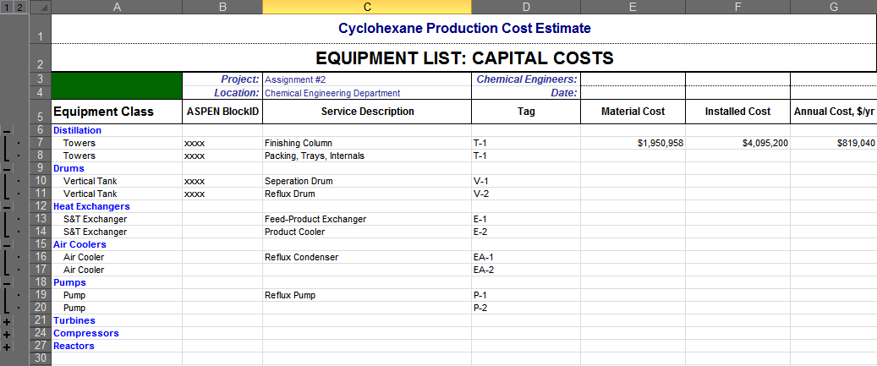

Table of Contents

Executive Summary…………………………………….….………….........................................3
System & Procedures ………………………………………………………………………..…..4
Results……..…………………………………………………………………………………..….5
Discussion ………….….………….………………………………………………………….…..7
Conclusion ………….….………….……………………………………………………………..7
Appendices.……………………………………………………………………………….…......8
APPENDIX I…………………..……...………………………………………………...8
APPENDIX II……………...…..…………………………………………………….….11
APPENDIX III…………………..………………………………………………..….…13
References…..………………………….……………………………………………….……….17

I - EXECUTIVE SUMMARY:

- Cyclohexane Production
The cyclohexane production schematic from previous homework was reconfigured using the real-life equipment. The objective of this homework was to produce 300 KMTA cyclohexane via hydrogenation of benzene in bubble column reactor in the presence of nickel catalyst. The reaction mixture is fed to the reactor to convert the raw materials into the cyclohexane where the conversion rate of the reactor is given to be 99.5 %. The hydrogen stream is introduced at 335 psia. Benzene feed is initially at 15 psia therefore to equate the pressures of the stream entering the mixer, a pump is used to pressurize the benzene feed up to 335 psia. The reactor inlet is preheated using the heater duty at the outlet if the reactor and acts as shell and tube heat exchanger. To cool down the reactor effluent, cooling water is used from the cooling tower designed for dry bulb temperature of 85 F. Using cyclometric chart, wet bulb temperature is identified, and temperature of the cooling water was calculated which was found to be 95 F. The cooled stream is then introduced in a high-pressure separator where gas phase obtained from the top is recycled to feed of the reactor. This recycled stream is compressed to the pressure to 335 psia in order to be introduced into the reactor along with hydrogen and benzene feed. Also, to avoid accumulation of unreacted components at the top of the high-pressure vessel, the purge is carried out of the system. The liquid phase obtained from the bottom of the separation vessel is split into two streams where one is recycled back to the reactor and the other is introduced into the low-pressure separating vessel. The recycled liquid stream is pressurized to 335 psia to be able to merge into the reaction mixture. Hence, to process cyclohexane in an actual chemical plant we will need to install a shell and tube heat exchanger system, a cooler, two pumps and a compressor. After running the simulation and doing cost analysis, the total capital cost was found to be $7,723,793. Total operating cost and the cost of raw materials for the utilities was found to be $7,577,079 and $3,186,005,18 respectively.
II – SYSTEMS AND PROCEDURES:

PROBLEM A: A schematic of refrigeration with flash tank economizer and two stage compressors was provided in the handout was utilized to solve this problem. The purpose of this problem was to simulate a three-stage compressor refrigeration system which was done by adding another set of a compressor, separator and a valve. The given physical properties were inserted in ASPEN simulation.

Using Transfer tool in ASPEN, the pressures from compressor 1, compressor 2 and compressor 3 were transferred to outlet pressures of Valve 2, Valve 1 and S3 respectively. Two Design Specs were also used. Chiller’s power was defined to not be more than 3 MW by varying the molar flow rate of the stream S10 which was taken to be the feed basis of 100 kmol/hour. Second, design spec was made by defining outlet pressure variables, VALVOUT and CHILLERO of Valve 3 and Chiller, and the difference between them was targeted to be equal to zero by varying outlet pressure of Valve 3. This assure the pressure across the chiller to be constant.
Optimization, in Model Analysis Tools, was performed to obtain the required total power as a function of interstage pressure. Variables, W1, W2, and W3 which are power of each compressor, were defined in Optimization tab and the sum of all three powers were minimized in Objective & Constraint tabs. The outlet pressures of the Valve 1 and Valve 2 were varied from 1 bar to 7 bar and 7 bar to 12 bar respectively, to meet the specified objective. The range of the pressures was guessed based on the known pressure range around the Valve 1 of the system from Assignment #3, i.e. 5.07 bar to 12 bars The pressure guessed for the second stage was calculated by,

$$P_{2}= \sqrt{P_{1}*P_{3}}$$

$$P_{2}= \sqrt{5.07*12.05}=7.75 bar$$

A Calculator was created to obtain the Coefficient of Performance (COP). The Powers of all the compressors, the duty of the Chiller and COP were defined as export variables. The calculation formulas were specified in Calculate/FORTRAN.
PROBLEM B: To run the simulation, two Design Specifications were defined. First, for the tear stream, for the present composition of hydrogen and benzene in the tear namely TEARH and TEARB. In the Spec tab the ratio of TEARH and TEARB was targeted to be equal to 3.3 by Varying the flow fraction of the splitter B4. Second design specification was defined for the product stream (PRODUCT) where the mass flow rate of the product was targeted to be equal to 300 by Varying the benzene feed (BZFEED) molar flow rate. The molar flow of hydrogen was reevaluated after the design spec was set up using the Calculator in ASPEN. Since the recycle liquid should not be more than 45 % of the benzene feed, the ratio of liquid recycles (RECLIQ) and the benzene feed (FEEDB) was made equal to 0.45 again using Calculator. New variables FEEDB, HNEW, and RECLIQ were defined in order to make the Fortran calculation.

III – RESULTS:

PROBLEM A: The results obtained of ASPEN optimization gave a COP of 2.16 for Total work of 1.39 MW.

Table 1: Compressors’ Work
Sampled variable | Initial value | Final value | Units
W1 | 0.069555263 | 0.725891269 | MW
W2 | 0.0355739719 | 0.3022339 | MW
W3 | 0.34703546 | 0.359681847 | MW
TOTAL Work |  | 1.38780702 | MW

Table 2: Interstage Pressures and Coefficient of Performance
Name | Value | Units
INTERSTAGE PRESSURE 1 | 5.07393789 | Bar
INTERSTAGE PRESSURE 2 | 7.7608866 | Bar
COP | 2.16168354

Table 3: Equipment used for cyclohexane production with the capital costs

Table 4: Utilities, Raw Material, Product with operating costs

Table 5: Raw Materials and Product
Parameters | Value | Units
Product | 300 | ktonne/year
Benzene Feed | 915.23 | lbmol/hr
Hydrogen Feed | 2864.68 | lbmol/hr

Table 6: Total Costs
Total Capital Cost | Total Operating Cost | Total Raw Material Cost | Product Revenue | Fuel Credits
$7,723,793 | $7,577,079 | $3,186,005,18.4 | $570,000,000 | $2393511.12

IV – DISCUSSION:

V – CONCLUSIONS:

PROBLEM B: The aim of this project was to simulate the actual production plant to produce cyclohexane using the bubble column reactor. The reactor used had the 99.5 % conversion. By focusing on the accurate utilities, a shell and tube heat exchanger system, a cooler, two pumps and a compressor were installed to process cyclohexane in a bubble column reactor. The total capital cost of equipment was calculated by utilizing the equations that calculate the cost of the equipment by taking in account of the indexes of the year 2010 and 2020 for a good estimation. The value of the total capital cost was found to be $7,723,793. The total operating cost was also evaluated utilizing the annual cost required for the maintenance of the equipment which was found to be $7,577,079. The total cost of the raw materials was evaluated to find out how much money should be spent on buying raw materials to produce 300 KMTA cyclohexane. The raw material cost was found to be $318,600,518.

VI – APPENDICES:

APPENDIX I:
PROBLEM B:

For Design Specifications in ASPEN Plus we used,
$$\frac{TEARH}{TEARB} = 3.3$$

$$HNEW = 3.13*FEEDB (SOLVER ASPEN)$$

Calculating equipment, installation, and annualized cost
For Shell and Tube Heat Exchanger and a Cooler:
$$\$\left(2010\right)=28000+54 {\left(A\left[m^{2}\right]\right)}^{1.2}$$

$$\$\left(2020\right)=\$\left(2010\right)*\frac{index (\$2020)}{index (\$2010)}$$
Where A can be found using,
$$Q=F_{T }A U ∆T_{LN}$$
Where, $∆T_{LN}$is given as,
$$∆T_{LN}=\frac{∆T_{1}-∆T_{2}}{ln(\frac{∆T_{1}}{∆T_{2}})}$$

The installation factor for the shell and tube heat exchanger is given to be 3.5 therefore,
$$Installation cost=3.5*purchasing cost \\ The a$$nnualized cost can be found using,
$$Annualized cost=\frac{4}{3}*installation cost$$
For Pumps
$$\$\left(2010\right)=8000+240 {\left(Q\left[\frac{L}{s}\right]\right)}^{0.9}$$

Installation factor is given to be 4.0. Also, the installation cost and annualized cost can be found from the same formulae.

For Compressor
$$\$\left(2010\right)=58000+20000 {\left(W\left[kW\right]\right)}^{0.6}$$

Installation factor is given to be 2.5. Also, the installation cost and annualized cost can be found from the same formulae.

For Drums (Vertical Vessel)
$$\$\left(2010\right)=11600+34 {\left(M\left[kg\right]\right)}^{0.85}$$
Where M is given as,
$$M[kg]= π D_{i} L t ρ_{STEEL}$$
Where t is the thickness of the walls of the drum and is given as,
$$t=\frac{P_{i}D_{i}}{2 S E-1.2 P_{i}}$$
Where,
Di is the internal diameter
Pi is the internal pressure of the drum + 10 % safety factor
E = welded efficiency
S = Stress material can take [=] ksi
Where,
$$I ksi=6.895\frac{N}{m^{2}}$$

Internal Diameter can be calculated using the residence time,
$$τ=\frac{V}{F}$$

Where volume of the vessel is given as,
$$V_{VESSEL}=2 V$$And the length is given as,
$$L=2 D_{i}$$
Where,
$$D_{I}={\left(\frac{2 V_{VESSEL}}{π}\right)}^{\frac{1}{3}}$$Installation factor is given to be 4.0. Also, the installation cost and annualized cost can be found from the same formulae.

APPENDIX II:
Figure 1: Optimized Refrigeration Process Flow Diagram
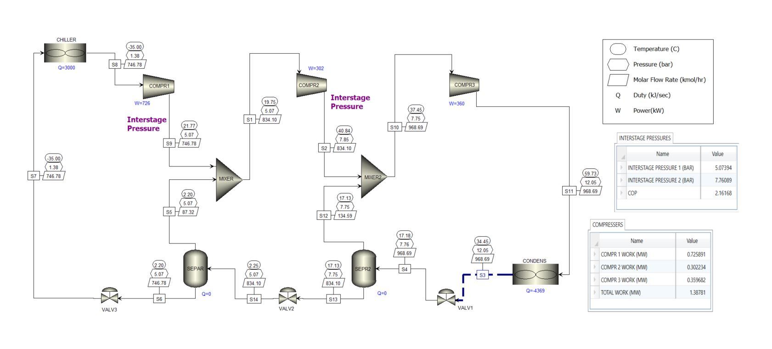
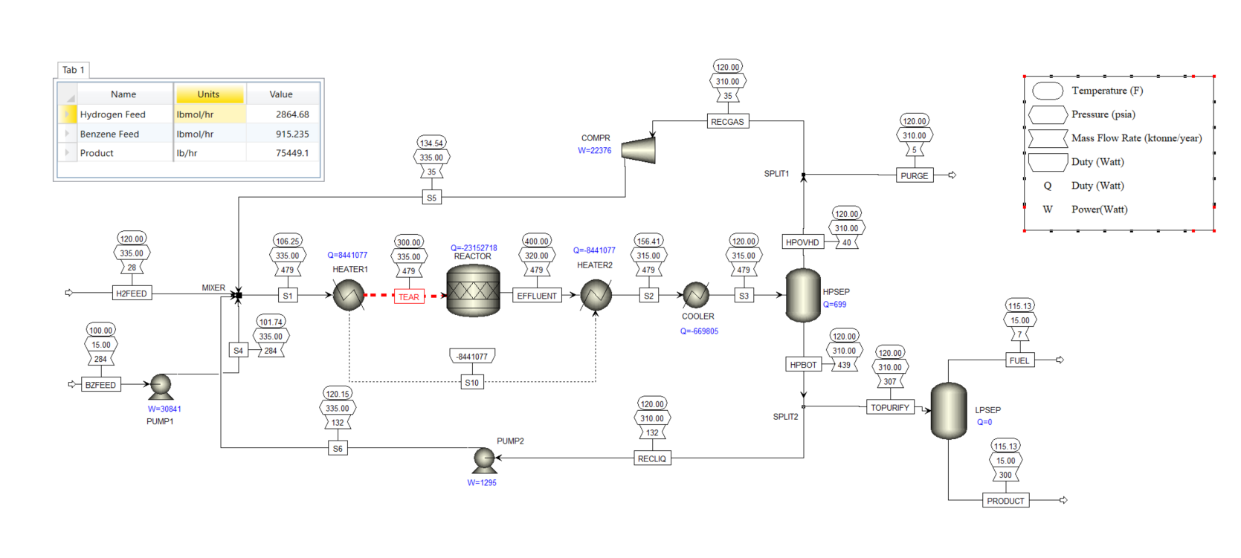
Figure 2: Cyclohexane Production Process Flow Diagram

APPENDIX III:
Problem A: Stream Summary - I

Problem A: Stream Summary - II
Problem B: Stream Summary - I

Problem B: Stream Summary - II

Problem A: Block Report (Operating Conditions)

CHILLER
Name | CHILLER
Property method | PENG-ROB
Use true species approach for electrolytes | YES
Free-water phase properties method | STEAM-TA
Specified temperature [C] | -35
Specified vapor fraction | 1
Calculated pressure [bar] | 1.3765645
Calculated temperature [C] | -35
Calculated vapor fraction | 1
Calculated heat duty [kJ/sec] | 2999.99958
Net duty [kJ/sec] | 2999.99958

Compr
Name | COMPR1
Property method | PENG-ROB
Use true species approach for electrolytes | YES
Free-water phase properties method | STEAM-TA
Specified discharge pressure [bar] | 5.06625
Isentropic efficiency | 0.75
Calculated brake horsepower [kW] | 725.891269
Net work required [kW] | 725.891269
Power loss [kW] | 0
Efficiency (polytropic / isentropic) used | 0.75
Calculated discharge pressure [bar] | 5.06625
Calculated pressure change [bar] | 3.6896855
Calculated pressure ratio | 3.68035788
Outlet temperature [C] | 21.7650001
Vapor fraction | 1
Isentropic power requirement [kW] | 544.418452
Inlet heat capacity ratio | 1.16843125

Compr
Name | COMPR2
Property method | PENG-ROB
Use true species approach for electrolytes | YES
Free-water phase properties method | STEAM-TA
Specified discharge pressure [bar] | 7.852687499
Isentropic efficiency | 0.75
Calculated brake horsepower [kW] | 302.2339
Net work required [kW] | 302.2339
Power loss [kW] | 0
Efficiency (polytropic / isentropic) used | 0.75
Calculated discharge pressure [bar] | 7.8526875
Calculated pressure change [bar] | 2.7864375
Calculated pressure ratio | 1.55
Outlet temperature [C] | 40.8400795
Vapor fraction | 36.8392252
Isentropic power requirement [kW] | 1
Inlet heat capacity ratio | 1.17902757

Compr
Name | COMPR3
Property method | PENG-ROB
Specified discharge pressure [bar] | 12.0466
Isentropic efficiency | 0.75
Calculated brake horsepower [kW] | 359.681847
Net work required [kW] | 359.681847
Power loss [kW] | 0
Efficiency (polytropic / isentropic) used | 0.75
Calculated discharge pressure [bar] | 12.0466
Calculated pressure change [bar] | 4.2966
Calculated pressure ratio | 1.5544
Outlet temperature [C] | 59.7260744
Vapor fraction | 1

Heater
Name | CONDENS
Property method | PENG-ROB
Specified temperature [C] | 35
Specified vapor fraction | 0
Calculated pressure [bar] | 12.2061811
Calculated temperature [C] | 35
Calculated vapor fraction | 0
Calculated heat duty [kJ/sec] | -4368.62123
Net duty [kJ/sec] | -4368.62123

Flash2
Name | SEPAR
Property method | PENG-ROB
Temperature [C]
Pressure [bar] | 5.06625
Specified heat duty [kJ/sec] | 0
Outlet temperature [C] | 2.19601703
Outlet pressure [bar] | 5.06625
Vapor fraction | 0.104690562

Flash2
Name | SEPR2
Property method | PENG-ROB
Temperature [C]
Pressure [bar] | 7.75
Specified heat duty [kJ/sec] | 0
Outlet temperature [C] | 17.1300671
Outlet pressure [bar] | 7.75
Vapor fraction | 0.138944852

Valve
Name | VALV1
Property method | PENG-ROB
Specified outlet pressure [bar] | 7.7608866
Valve pressure specification (design mode) | P-OUT
Calculated outlet pressure [bar] | 7.7608866
Calculated pressure drop [bar] | 4.2857134

Valve
Name | VALV2
Property method | PENG-ROB
Specified outlet pressure [bar] | 5.07393789
Valve pressure specification (design mode) | P-OUT
Calculated outlet pressure [bar] | 5.07393789
Calculated pressure drop [bar] | 2.67606211

Valve
Name | VALV3
Property method | PENG-ROB
Specified outlet pressure [bar] | 1.37660145
Valve pressure specification (design mode) | P-OUT
Calculated outlet pressure [bar] | 1.37660145
Calculated pressure drop [bar] | 3.68964855
VII – REFERENCES:

1. “U.S. Energy Information Administration - EIA - Independent Statistics and Analysis.” EIA.
2. Munters, “Psychrometric Chart.”
3. User, Super. “Cooling Water Prices: Utilities Cost Database.” Intratec.us.
4. Rashidi et al, “Exergetic optimisation of a multi-stage compression transcritical refrigeration cycle.” 2016’
5. Chemicals, Chemicals Products, Chemicals Manufacturers, Chemicals Suppliers and Exporters Directory.

Problem 5: Cyclohexane production(Continued)

For the cyclohexane production process of Assignment #4, consider the option of increasing the cyclohexane recovery by replacing the low pressure separator with a distillation column. Design the distillation column to maximize the recovery of cyclohexane and update your simulation. Recalculate your fixed capital investment and the operating costs. Update the list of all equipment (except the reactor) and recalculate the total capital cost. Update the list of all utilities and calculate the total operating cost, including the cost of raw materials, revenues from the product and credits for fuel. Start again with your own simulation from Assignment #4. Plant capacity is 300 KMTA of cyclohexane with plant operating data defined in Assignment #3. Cooling water is available by a nearby cooling tower that has been designed for dry bulb temperature of 85 deg F, relative humidity of 70% and an approach temperature of 10 deg C. The maximum hot water temperature was taken as 45 deg C for the design of the cooling tower. Multiple pressure levels of steam are available by a steam plant nearby.

Required Report Sections

- A. Outline your steps you followed to reach your final column design
- B. Final process flowsheet printout
- C. ASPEN report for the distillation column
- D. Heat and Weight Balance for the entire unit
- E. List of all equipment for with the capital costs (see example below)
- F. List of utilities, raw materials and products with operating costs



Table of Contents

Executive Summary…………………………………….….………….........................................3
System & Procedures ………………………………………………………………………..…..4
Results……..…………………………………………………………………………………..….5
Discussion ………….….………….………………………………………………………….…..7
Conclusion ………….….………….……………………………………………………………..7
Appendices.……………………………………………………………………………….…......8
APPENDIX I…………………..……...………………………………………………...8
APPENDIX II……………...…..…………………………………………………….….11
APPENDIX III…………………..………………………………………………..….…13
References…..………………………….……………………………………………….……….17

I - EXECUTIVE SUMMARY:

- Cyclohexane Production
The cyclohexane production schematic from previous homework was reconfigured using the real-life equipment. The objective of this homework is to 1) increase the recovery of cyclohexane via hydrogenation of benzene in bubble column reactor in the presence of nickel catalyst by keeping the plant capacity 300 KMTA and 2) Recalculate the fixed capital investment, total operating costs, and total capital costs. The increase of recovery of cyclohexane will be achieved using three major steps which is briefly discussed in this section. To achieve the maximum recovery of the cyclohexane first, the TOPURIFY stream exiting from the high-pressure separator is introduced in SEP2, a two-product separator unit, to compute the recovery and purity of the cyclohexane. The advantage of using SEP2 is that we can specify the split fractions required in the product streams. The optimal pressure at which the recovery of cyclohexane is 0.9999 was found to be 1.03 bar (~15 psia). The found pressure was then utilized to simulate DISTWU, a shortcut model, to compute actual reflux ratio, number of stages, feed stage, and distillate to feed ratio, which was found to be 0.37, 10, 6, and 0.038 respectively. The information found from the DISTWU model is then used to simulate RADFRAC, a rigorous model, to finally compute maximum recovery of cyclohexane which was then found to be 0.9986 at the production rate of 300 KMTA. Unlike shortcut model, rigorous model calculations are accurate since the model performs stage by stage calculations, does not consider ideal behavior between liquid and gas phases, allow multiple types of design specifications, and allow multiple column configurations.
The list of equipment will be slightly modified since now we will be using a reflux pump and a distillation column in addition to a shell and tube heat exchanger system, a cooler, two pumps and a compressor. After running the simulation and doing cost analysis, the total capital cost was found to be $4,589,103. Total operating cost and the cost of raw materials for the utilities was found to be $116,114.09 and $216,563,328.00 respectively.

II – SYSTEMS AND PROCEDURES:
PROBLEM A:
To run the simulation, two Design Specifications were defined. Using the data from Assignment #3, for the tear stream, for the present composition of hydrogen and benzene in the tear namely TEARH and TEARB. In the Spec tab the ratio of TEARH and TEARB was targeted to be equal to 3.3 by Varying the flow fraction of the splitter B4. Second design specification was defined for the product stream (PRODUCT) where the mass flow rate of the product was targeted to be equal to 300 KMTA by Varying the benzene feed (BZFEED) molar flow rate. The molar flow of hydrogen was reevaluated after the design spec was set up using the Calculator in ASPEN. Since the recycle liquid should not be more than 45 % of the benzene feed, the ratio of liquid recycles (RECLIQ) and the benzene feed (FEEDB) was made equal to 0.45 again using the Calculator. New variables FEEDB, HNEW, and RECLIQ were defined in order to make the Fortran calculation.
In order to replace the low-pressure separator with a rigorous distillation column the following steps must be taken:
1. SEP2 Model: To achieve the maximum recovery of the cyclohexane, TOPURIFY stream exiting from the high-pressure separator is introduced in SEP2, a two-product separator unit, to compute the recovery and purity of the cyclohexane. The required split fractions for the product was specified. After running the simulation, the optimal pressure to achieve the maximum recovery was noted.
2. DISTWU Model: The pressure obtained from the SEP2 simulation is then utilized to run DISTWU, a shortcut model which determines the minimum and actual reflux ratio, minimum and actual number of trays, and optimal feed tray location. In DISTWU model, we assumed the reboiler pressure equals to the feed pressure (15 psia) and the pressure drop across the column to be 1 psia. The reflux ratio was defined to be R= -1.15 R_{MIN}. Condenser was specified as partial condenser with vapor distillate since the fuel stream is exiting the top of the column in the vapor phase. Actual reflux ratio, number of stages, feed stage, and distillate to feed ratio was determined after plugging in the above information.
3. RADFRAC Model: The information found from the DISTWU model is then utilized to simulate RADFRAC, a rigorous model, to compute maximum recovery of cyclohexane. Again, partial vapor condenser was selected in ASPEN and the condenser utility was specified to be cooling water. Feed location, reflux ratio, and distillate to feed ratio was specified to be stage #6, 0.37, and 0.038 respectively using the data from DISTWU model.
The simulation was the ran using RADFRAC and the recovery of cyclohexane was then found to be 0.9986 at the production rate of 300 KMTA.

III – RESULTS:

PROBLEM A:

Table 1: Equipment used for cyclohexane production with the capital costs

Table 2: Utilities, Raw Material, Product with operating costs

Table 3: Raw Materials and Product
Parameters | Value | Units
Product | 300 | ktonne/year
Benzene Feed | 901.007 | lbmol/hr
Hydrogen Feed | 2820.15 | lbmol/hr
Cyclohexane Recovery | 0.9999

Table 4: Total Costs
Total Capital Cost | Total Operating Cost | Total Raw Material Cost | Product Revenue
$4,589,103 | $116,114.09 | $216,563,328.00 | $312,000,000.00

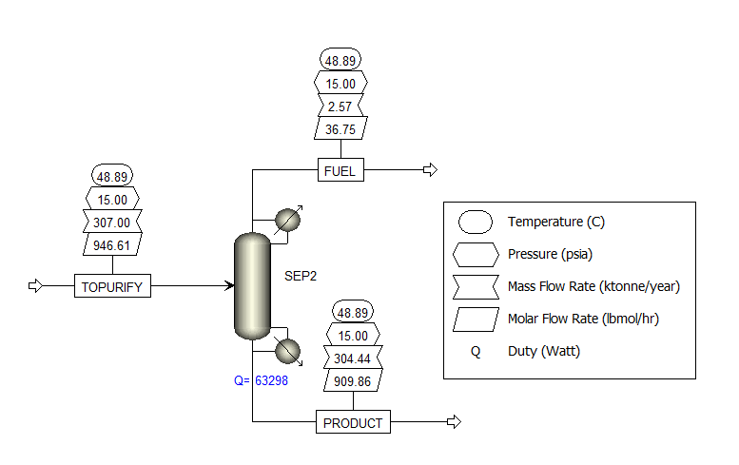
Figure 1: Results of the SEP2 simulation

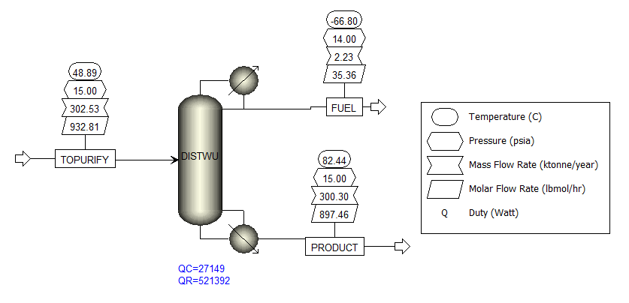
Figure 2: Results of the DISTWU simulation

V – CONCLUSIONS:
PROBLEM A: The aim of this project was to simulate the actual production plant to produce cyclohexane using the bubble column reactor. By focusing on the accurate utilities, such as, rigorous distillation column, a shell and tube heat exchanger system, a cooler, reflux pumps and a compressor were installed to maximize the recovery of cyclohexane. After replacing a low-pressure separator with a distillation column, the recovery of cyclohexane was increased from 98 % to 99.86 %. In addition, the total operating costs, total capital costs, and fixed capital investments were recalculated by taking additional equipment into account. The total capital cost was calculated by utilizing the equations that calculate the cost of the equipment by taking in account of the indexes of the year 2010. The value of the total capital cost was found to be $4,589,103. The total operating cost was also evaluated utilizing the annual cost required for the maintenance of the equipment which was found to be $116,114.09. The total cost of the raw materials was evaluated to find out how much money should be spent on buying raw materials to produce 300 KMTA cyclohexane. The raw material cost was found to be $216,563,328.00.

VI – APPENDICES:

APPENDIX I:
PROBLEM A:
For Design Specifications in ASPEN Plus we used,
$$\frac{TEARH}{TEARB} = 3.3$$

$$HNEW = 3.13*FEEDB (SOLVER ASPEN)$$

Calculating equipment, installation, and annualized cost
For Shell and Tube Heat Exchanger, Cooler and Condenser:

Utilizing the cost data for the year 2010 we have,
$$\$\left(2010\right)=28000+54 {\left(A\left[m^{2}\right]\right)}^{1.2}$$

Where A can be found using,
$$Q=F_{T }A U ∆T_{LN}$$
Where, $∆T_{LN}$is given as,
$$∆T_{LN}=\frac{∆T_{1}-∆T_{2}}{ln(\frac{∆T_{1}}{∆T_{2}})}$$

The installation factor for the shell and tube heat exchanger is given to be 3.5 therefore,
$$Installation cost=3.5*purchasing cost \\ The a$$nnualized cost can be found using,
$$Annualized cost=\frac{4}{3}*installation cost$$
For Reflux Pumps
$$\$\left(2010\right)=8000+240 {\left(Q\left[\frac{L}{s}\right]\right)}^{0.9}$$

Installation factor is given to be 4.0. Also, the installation cost and annualized cost can be found from the same formulae.

The increased in pressure is given as,
$$∆P= ρ g h$$

Where, $∆P$ is the increase in pressure, g is force of gravity and h is the height of the column.

For Compressor
$$\$\left(2010\right)=58000+20000 {\left(W\left[kW\right]\right)}^{0.6}$$

Installation factor is given to be 2.5. Also, the installation cost and annualized cost can be found from the same formulae.

For Drums (Vertical Vessel)
$$\$\left(2010\right)=11600+34 {\left(M\left[kg\right]\right)}^{0.85}$$
Where M is given as,
$$M[kg]= π D_{i} L t ρ_{STEEL}$$
Where t is the thickness of the walls of the drum and is given as,
$$t=\frac{P_{i}D_{i}}{2 S E-1.2 P_{i}}$$
Where,
Di is the internal diameter
Pi is the internal pressure of the drum + 10 % safety factor
E = welded efficiency
S = Stress material can take [=] ksi
Where,
$$I ksi=6.895\frac{N}{m^{2}}$$

Internal Diameter can be calculated using the residence time,
$$τ=\frac{V}{F}$$
Where volume of the vessel is given as,
$$V_{VESSEL}=2 V$$And the length is given as,
$$L=2 D_{i}$$

Where,
$$D_{I}={\left(\frac{2 V_{VESSEL}}{π}\right)}^{\frac{1}{3}}$$Installation factor is given to be 4.0. Also, the installation cost and annualized cost can be found from the same formulae.

Table 5: Standard Prices for 2010 Used for Cost Estimation
Utility Class | Prices | Units
Electricity | 0.09 | USD/KWh
High-Pressure Steam | 11.45 | USD/1000 lb
Medium-Pressure Steam | 9.50 | USD/1000 lb
Low-Pressure Steam | 8.48 | USD/1000 lb
Cooling Water | 0.08 | USD/1000 gal
Fuel Gas (LHV) | 7.30 | USD/MMBtu
Raw Materials
Benzene | 760 | USD/MT
Hydrogen | 2.60 | USD/MSCF
Product
Cyclohexane | 1040 | USD/MT

Table 6: Installation Factors Used for Calculations
Equipment | Installation Factor
Compressor | 2.5
Distillation Column | 4.0
Heat Exchanger | 3.5
Pressure Vessels | 4.0
Pumps | 4.0
Fired Heater | 2.0
Other | 2.5

APPENDIX II: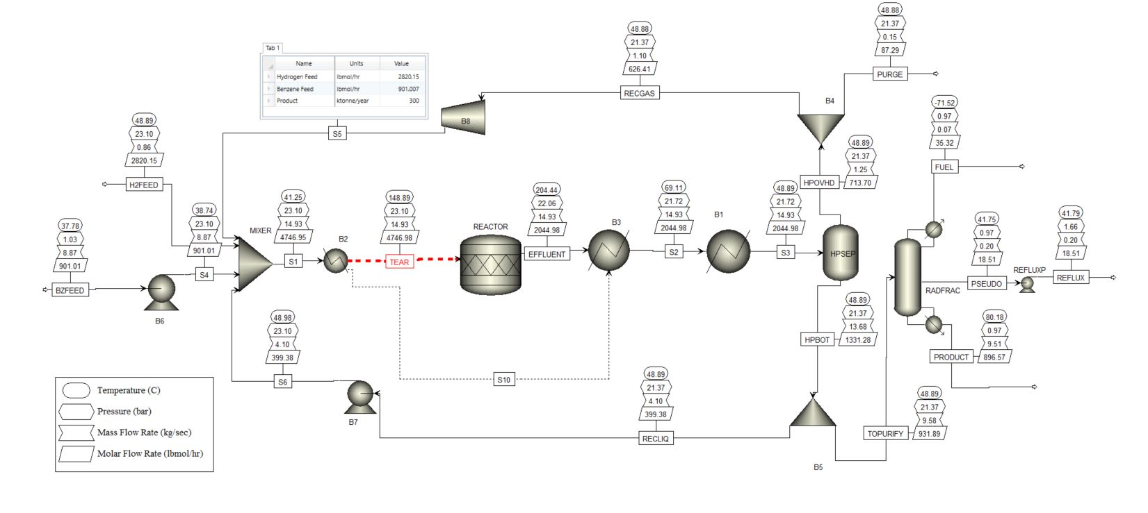
Figure 3: Cyclohexane Production Process Flow Diagram
APPENDIX III:

Probem A: Stream Summary

Probem A: Stream Summary

Problem A: Block Summary (Operating Conditions)

REFLUX PUMP
Outlet Pressure (psia) | 10.0138
Pump Efficiency | 0.75

VII – REFERENCES:

1. “U.S. Energy Information Administration - EIA - Independent Statistics and Analysis.” EIA.
2. Munters, “Psychrometric Chart.”
3. User, Super. “Cooling Water Prices: Utilities Cost Database.” Intratec.us.
4. Rashidi et al, “Exergetic optimisation of a multi-stage compression transcritical refrigeration cycle.” 2016’
5. Chemicals, Chemicals Products, Chemicals Manufacturers, Chemicals Suppliers and Exporters Directory.
6. http://what-when-how.com/Tutorial/topic-1776jn0513/Teach-Yourself-the-Basics-of-Aspen-Plus-51.html

